**The Crane Fund 2023/24 Report**

Please find a report below outlining the financial assistance provided to students from the Crane Fund for the 2023/24 academic year.

Please note that numbers of 5 and below are suppressed (<5) in order that individual students cannot be identified.

Contents

1. Overview of the Fund 1

2. Application Outcomes 1

3. Awards and Spending by Term and Category 2

4. Applications by Fee Status 4

5. Applications by course level 5

5. Applications and Award Contributions by College 5

6. Reasonings behind unsuccessful applications 7

### Overview of the Fund

The Crane's Fund provides financial assistance to students in financial need who need treatment for physical or mental illness. The treatment applied for should not be conveniently or readily obtainable under the NHS or the University.

In 2023/24, the Fund provided awards of up to £1,800 to assist students with medical costs. Students were able to access up to £1,800 during the course of the academic year.

Changes were made to the eligibility criteria for the Fund during 2023/24. From 2nd April 2024, students were no longer eligible to apply to the fund for support with costs for autism or ADHD assessment and private medication costs. Additionally, the time frame within which students were able to claim their awards was reduced to 1 year from the date the award was made.

### Application Outcomes

Figure 1a. Table to show the breakdown of application outcomes by category

|  |  |  |  |  |
| --- | --- | --- | --- | --- |
|  | Successful Applications | Unsuccessful Applications | Withdrawn Applications | **Totals** |
| Mental Health | 131 | 63 | 15 | **209** |
| Neurodiversity | 91 | 55 | 10 | **156** |
| Physical Health | 13 | 16 | <5 | **33** |
| **Totals** | **235** | **134** | **29** | **398** |

Figure 1b. Chart to show the breakdown of application outcomes by category.

### Awards and Spending by Term and Category

The average award for 2023/24 was £1,090.80. In 2023/24 37 students received £1,800 in one application. In 2023/24, <5 students received £1,800 over 2 or more applications.

Figure 2 a. Bar chart to show amount awarded by treatment category and term*

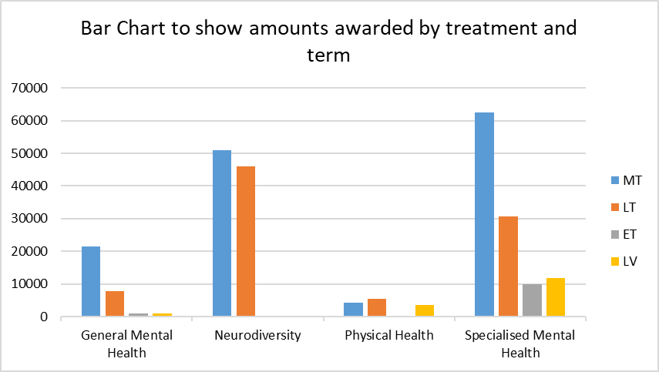

Figure 2b. Table to show amount awarded by treatment category* per term

|  |  |  |  |  |  |
| --- | --- | --- | --- | --- | --- |
| **Treatment Category** | **Awards Made by Term** | | | |  |
| MT | LT | ET | LV | **Total** |
| Neurodiversity | £50,870.50 | £45,997 | £0 | £0 | **£96,867.50** |
| General Mental Health | £21,558 | £7795.50 | £1000 | £900 | **£31,253.50** |
| Specialised Mental Health | £62,385 | £30,662 | £9,925 | £11,750 | **£114,722.00** |
| Physical Health | £4418.50 | £5376 | £0 | £3700 | **£13,494.50** |
| **Total** | **£139,232** | **£89,830.50** | **£10,925** | **£16,350** | **£256,337.50** |

Figure 2c. Table to show the breakdown of successful applications by treatment category* and award value category

|  |  |  |  |  |  |  |  |  |  |  |  |  |  |  |  |  |  |
| --- | --- | --- | --- | --- | --- | --- | --- | --- | --- | --- | --- | --- | --- | --- | --- | --- | --- |
|  | Number of Students Awarded Per Category Per Term | | | | | | | | | | | | | | | |  |
| **MT** | | | | **LT** | | | | **ET** | | | | **LV** | | | |
| Award Value Category | Neurodiversity | General Mental Health | Specialised Mental Health | Physical Health | Neurodiversity | General Mental Health | Specialised Mental Health | Physical Health | Neurodiversity | General Mental Health | Specialised Mental Health | Physical Health | Neurodiversity | General Mental Health | Specialised Mental Health | Physical Health | **Total** |
| £0-£499 | <5 | 7 | <5 | <5 | 6 | <5 | <5 | <5 | <5 | <5 | <5 | <5 | <5 | <5 | <5 | <5 | **31** |
| £500-£999 | 20 | <5 | 15 | <5 | 27 | <5 | <5 | <5 | <5 | <5 | <5 | <5 | <5 | <5 | <5 | <5 | **79** |
| £1000-£1499 | 11 | 6 | 17 | <5 | 13 | <5 | <5 | <5 | <5 | <5 | <5 | <5 | <5 | <5 | <5 | <5 | **58** |
| £1500-£1800 | 12 | 5 | 17 | <5 | 20 | <5 | <5 | <5 | <5 | <5 | <5 | <5 | <5 | <5 | 6 | <5 | **67** |
| **Total** | **129** | | | | **85** | | | | **9** | | | | **12** | | | | **235** |

*Talking therapy and counselling treatments were categorised underneath the General Mental Health Category. CBT, CAT, EMDR and trauma therapy were categorised under Specialised Mental Health Treatment.

### Applications by Fee Status

Figure 3a. Chart showing breakdown of application outcomes by fee status.

Figure 3b. Table to show application outcomes by fee status

|  |  |  |  |  |
| --- | --- | --- | --- | --- |
| **Fee status** | **Successful applications** | **Unsuccessful applications** | **Withdrawn applications** | **Total applications** |
| Home/UK | 175 | 107 | 22 | 304 |
| Overseas | 60 | 30 | <5 | 94 |
| **Total** | **235** | **137** | **26** | **398** |

### Applications by course level

Figure 4a. Chart to show application outcomes by course level, Undergraduate compared with Postgraduate.

Figure 4b. Table to show application outcomes by course level (Postgraduate compared with Undergraduate).

|  |  |  |  |  |
| --- | --- | --- | --- | --- |
| **Course level** | **Successful applications** | **Unsuccessful applications** | **Withdrawn applications** | **Total applications** |
| Undergraduate | 181 | 112 | 19 | 312 |
| Postgraduate | 54 | 25 | 7 | 86 |
| **Total** | **235** | **137** | **26** | **398** |

### Applications and Outcomes by College

Figure 5a. Bar chart to show number of applications made by College.

Figure 5b. Table to show application outcomes per College.

|  |  |  |  |  |
| --- | --- | --- | --- | --- |
| **College** | **Award** | **Reject** | **Withdrawn** | **Total** |
| Christ’s College | 12 | <5 | <5 | 17 |
| Churchill College | 15 | <5 | <5 | 17 |
| Clare College | <5 | 7 | <5 | 15 |
| Clare Hall | <5 | <5 | <5 | 6 |
| Corpus Christi College | <5 | <5 | <5 | <5 |
| Darwin College | <5 | <5 | <5 | 8 |
| Downing College | 10 | 7 | <5 | 17 |
| Emmanuel College | <5 | <5 | <5 | 10 |
| Fitzwilliam College | <5 | <5 | <5 | 9 |
| Girton College | 8 | 11 | <5 | 20 |
| Gonville & Caius College | <5 | <5 | <5 | 7 |
| Homerton College | 19 | 12 | <5 | 33 |
| Hughes Hall | 6 | 6 | <5 | 12 |
| Jesus College | 12 | <5 | <5 | 16 |
| King’s College | 11 | <5 | <5 | 17 |
| Lucy Cavendish College | 18 | 10 | <5 | 29 |
| Magdalene College | 11 | <5 | <5 | 15 |
| Murray Edwards College | 10 | <5 | <5 | 12 |
| Newnham College | 11 | 8 | <5 | 21 |
| Pembroke College | 8 | 6 | <5 | 15 |
| Peterhouse College | <5 | <5 | <5 | <5 |
| Queen’s College | 7 | <5 | <5 | 9 |
| Robinson College | <5 | <5 | <5 | 10 |
| Selwyn College | <5 | <5 | <5 | <5 |
| Sidney Sussex College | <5 | <5 | <5 | 8 |
| St Catharine’s College | <5 | <5 | <5 | <5 |
| St Edmund’s College | 11 | <5 | <5 | 15 |
| St John’s College | 9 | <5 | <5 | 11 |
| Trinity College | <5 | <5 | <5 | 7 |
| Trinity Hall | 6 | 6 | <5 | 12 |
| Wolfson College | 10 | 6 | <5 | 17 |
| **Total:** | 235 | 134 | 29 | **398** |

### Reasonings behind unsuccessful applications

Students were unsuccessful in receiving support from the fund, for the following reasons:

* No tutor supporting statement
* No GP letter provided
* Out-of-date GP letter provided
* No diagnosis in GP letter
* Dental costs
* Retrospective application
* Savings/spare income
* Already received Crane’s funding
* Non UK-based treatment provider
* Treatment doesn’t fall under NICE guidelines
* Long-term treatment with no end date
* No student loan
* Treatment not supported by Crane’s
* Equipment or travel costs
* ADHD/autism assessment/medication after rule change
* Student close to course end date
* Not in financial need
* High living costs

Figure 6a Table to show number of unsuccessful applications per rejection reason.

|  |  |
| --- | --- |
| **Reason for unsuccessful Application** | **Number of applications** |
| Close to course end date | <5 |
| Dental Costs | <5 |
| High Living Costs | <5 |
| Long-term Treatment | <5 |
| No Diagnosis | <5 |
| No Student Loan | 7 |
| No Tutor Statement | 8 |
| No/Out-of-date GP letter | 54 |
| Non UK-based treatment provider | <5 |
| Not in financial need | <5 |
| Previously funded for this treatment | <5 |
| Savings/spare income | 25 |
| Treatment not supported by Cranes | 8 |
| Treatment not under NICE guidelines | 6 |
| **Total** | **134** |

Figure 6b Bar chart to show number of unsuccessful applications per rejection reason.