The Council of the School of the Biological Sciences (CSBS)
Undergraduate Student Representative
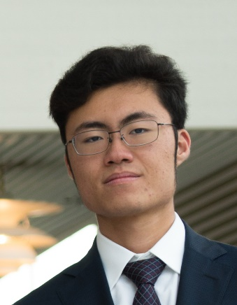

Stanley QUEK (stkq2)
St John’s College

I am second year undergraduate studying Part 1B Natural Sciences Biology and I hope to represent you as your Undergraduate Student Representative to the Council of the School of Biological Sciences for the academic year. In Singapore, I am a Council member of the Singapore Institute of Biology, and over two years I have been heavily involved in pushing for the advancement of teaching of Biology in the schools of Singapore. Previously, I have been tasked with leading the introduction of national competitions, and have had experience working with members of the Ministry of Education. I already possess behind the scenes insights on what is effective and beneficial in education, and with your feedback I will strive to implement many of the policies and improvements you have been wishing to see. I will fight for the concerns that you have been voicing. These issues transcend above the level of individual courses, instead, they are inherent to the mindset through which our education was crafted.
I want to create an environment where we can all enjoy our learning without having that enthusiasm brought down by needless worries. I want us to be able to feel the same passion we have for what we are learning at the start of term and at the end of term. I will dedicate myself to working towards that goal. At the same time, I will be listening keenly to your feedback in the same way I have when I was a course representative in 1A.
I am eager to play an active role in shaping education, and with your support, guidance from my seniors, and encouragement from my juniors, I will represent your views and your concerns in the Council and fight for our education.

At your service,
Stanley Quek

