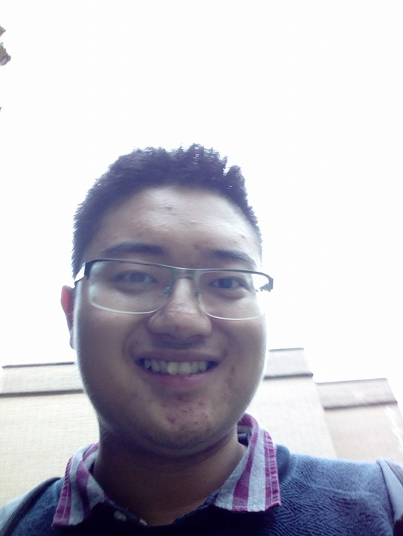
Why vote for me?

We are all empowered. Beyond the horizon of university, lies a universe of possibilities. Cambridge is the final rung on our ladder of formalised education, positioning us to leap forward towards tomorrow. Our time spent here is short but precious. We must do all that we can to seize everything from our course, and to take our future by the reigns and ride into battle.

It is my fundamental belief in our collective right to influence how our education in the Biological Sciences is conducted that fuels my passion to run for representative for our course.

My name is James Zhang, I am a first year medic. If elected, I will hit the ground running, utilising the Christmas vacation to extract all the wisdom from the previous representative and from our course organisers, so from day one I can begin working for you. I plan to set up frequent individual meetings with students from all parts of the course to obtain as many different perspectives as I can. Fuelled with these viewpoints, I will compile and constantly update an adapting representation of our ideas and relay that at the Council meetings. Transparency and trust is important, thus I shall publish reports to inform of the activities and decisions on our course.

I am physically and mentally prepared for the challenges ahead, I know there shall be many Friday evenings when I work late into the night for our cause, but when I am sweating and my vision is blurry, I will know I have done my duty. I have had experience in this area before. During secondary school I have sat on my school council for a number of years, relaying my follow students' ideas and opinions on a huge variety of issues. In the summer before university, I was chosen to be on the youth advisory board of the U.K. wide charity Groundwork. I was elected co-chairman at our first meeting, and in the months that followed, I have had plenty of experience chairing meetings, compiling feedback from our associates across the country, and writing reports on decisions the organisation has made.

Some may claim a year is too short a time for real change, to them I say this: the tide of history can be altered in a singular moment, and the last time I checked a year is made up of many moments!

I would cherish and fully utilise this opportunity to work for you, and I am grateful for your support!

Thank you.

(If you have any questions, please feel free to email me at zz357@cam.ac.uk)

Yours truly,

James Zhang

