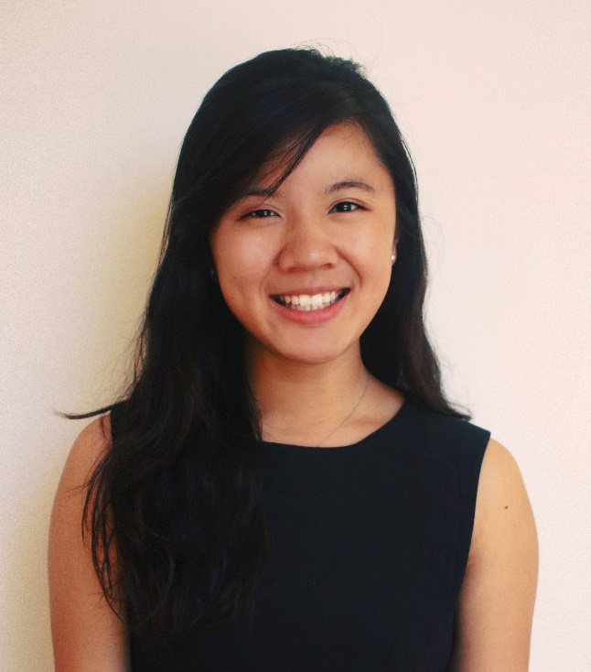
JESS TAN
UNDERGRAD REP
Council of Humanities & Social Sciences

I am running for this position because I believe that student opinion is essential to creating representative curriculums. Prior to reading law at Cambridge, I completed a BA at an American liberal arts college, where I took a wide variety of courses including history, politics, and philosophy. My previous academic experience therefore allows me to better understand and represent students’ interests across various subjects.
One of the key challenges for Council this year will be decolonization. Already, there are established decolonization working groups in subjects like history, HSPS and law. I am the right person to navigate this complex issue for three reasons. First, I am a British colonial subject: born in colonial Hong Kong and raised in the city’s immediate post-colonial context. Second, I have taken academic courses on array of related topics such as postcolonial theory, Black feminist thought, and immigrant/diasporic literatures. Third, I am actively involved in the Decolonize Law working group and am also connected to key members of the broader Decolonize Cambridge movement.
I also have experience representing student interests on an institutional level. Sitting on the Chaplaincy Committee of my previous university, I successfully advocated for hiring a Muslim Chaplain and assisted in selecting a LGBTQ-friendly Protestant Chaplain. Currently, I serve as BME Officer at Lucy Cavendish. All that to say, I am an organized and approachable person who would love to hear from you!

